SCHOOLOFCOMPUTER SCIENCE AND ARTIFICIAL INTELLIGENCE |  |  |  |  | DEPARTMENTOFCOMPUTER SCIENCE ENGINEERING
ProgramName:B. Tech |  |  |  | AssignmentType: Lab |  |  | AcademicYear:2025-2026
CourseCoordinatorName |  |  |  | Venkataramana Veeramsetty
Instructor(s)Name |  |  |  | Dr. V. Venkataramana (Co-ordinator)  Dr. T. Sampath Kumar  Dr. Pramoda Patro  Dr. Brij Kishor Tiwari  Dr.J.Ravichander  Dr. Mohammand Ali Shaik  Dr. Anirodh Kumar  Mr. S.Naresh Kumar  Dr. RAJESH VELPULA  Mr. Kundhan Kumar  Ms. Ch.Rajitha  Mr. M Prakash  Mr. B.Raju  Intern 1 (Dharma teja)  Intern 2 (Sai Prasad)  Intern 3 (Sowmya)  NS_2 ( Mounika)
CourseCode |  |  | 24CS002PC215 | CourseTitle |  | AI Assisted Coding
Year/Sem |  |  | II/I | Regulation |  | R24
DateandDay  of Assignment |  |  | Week6 - WednesDay | Time(s)
Duration |  |  | 2 Hours | Applicableto  Batches
AssignmentNumber:12.3(Presentassignmentnumber)/24(Totalnumberofassignments)
 | Q.No. | Question |  |  |  |  |  | ExpectedTime  to complete
 | 1 | Lab 12 – Algorithms with AI Assistance: Sorting, searching, and optimizing algorithms  Lab Objectives  - To implement classical algorithms (sorting, searching) with the help of AI tools.  - To analyze AI suggestions for efficiency and correctness.  - To explore AI-assisted optimizations of existing algorithms.  - To compare naive vs. optimized approaches generated by AI.  Learning Outcomes  After completing this lab, students will be able to:  • Implement sorting and searching algorithms using AI suggestions.  • Compare AI-generated algorithm variants in terms of readability and efficiency.  • Use AI to optimize brute-force algorithms into more efficient ones.  • Analyze algorithm complexity (time and space) with AI explanations.  • Critically reflect on correctness, clarity, and maintainability of AI-generated algorithms.  Task Description #1 – Linear Search implementation  Task: Write python code for linear_search() function to search a value in a list and extract it’s index.  CODE & OUPUT:  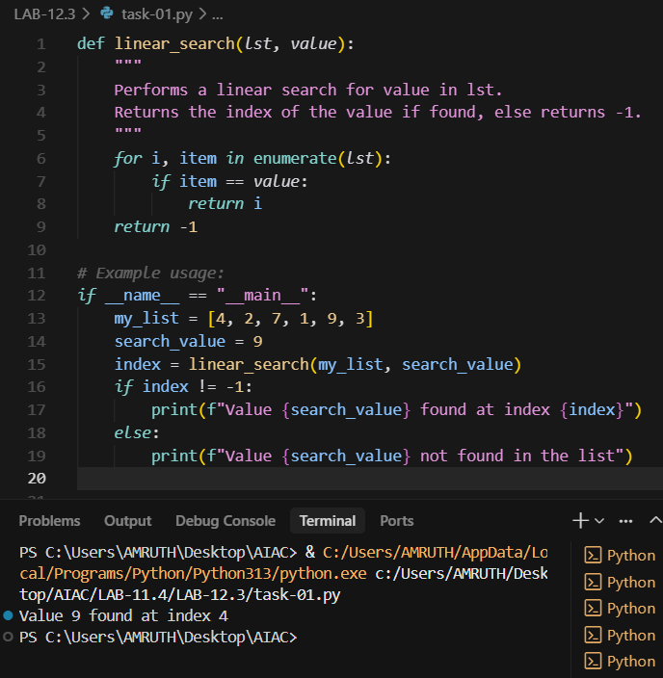  Task Description #2 – Sorting Algorithms  Task: Ask AI to implement Bubble Sort and check sorted output  CODE & OUPUT:  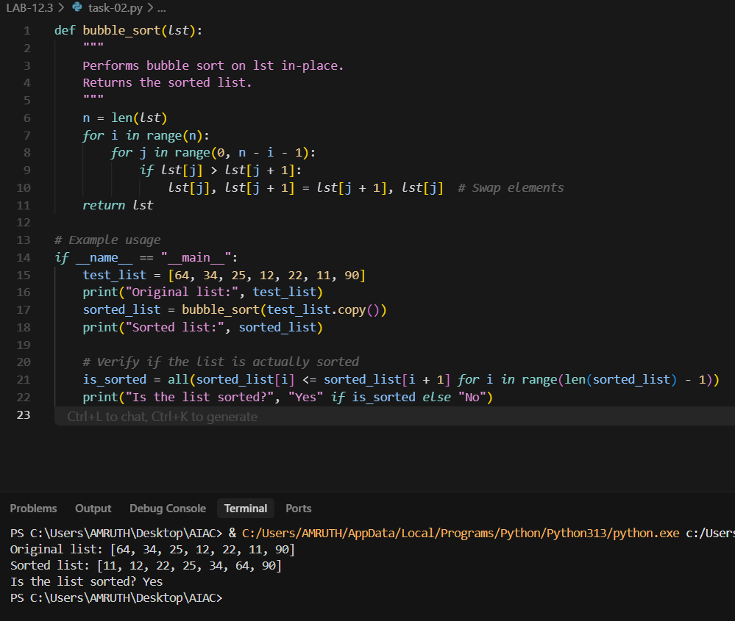  Task Description #3 – Optimization  Task: Write python code to solve below case study using linear optimization  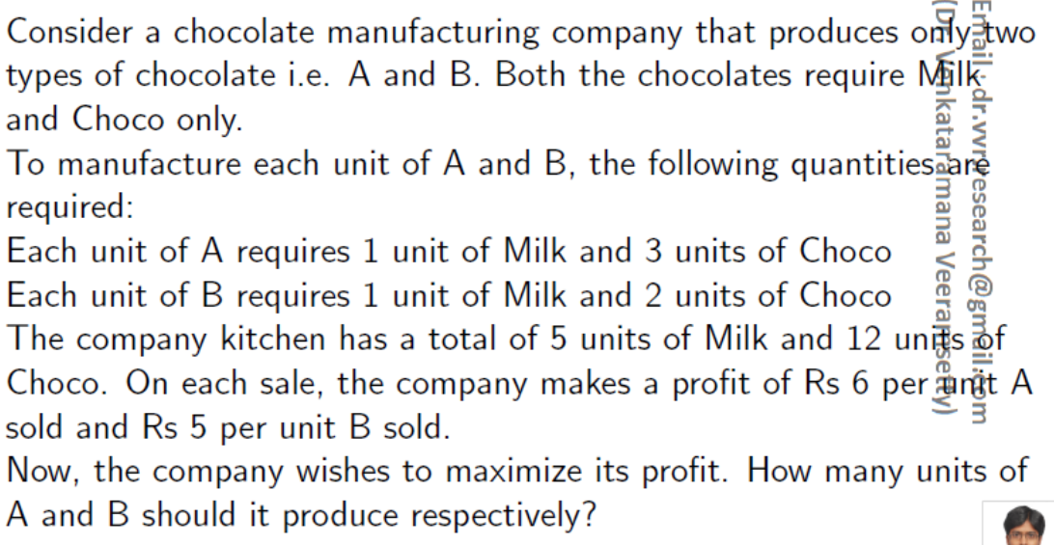  CODE & OUPUT:  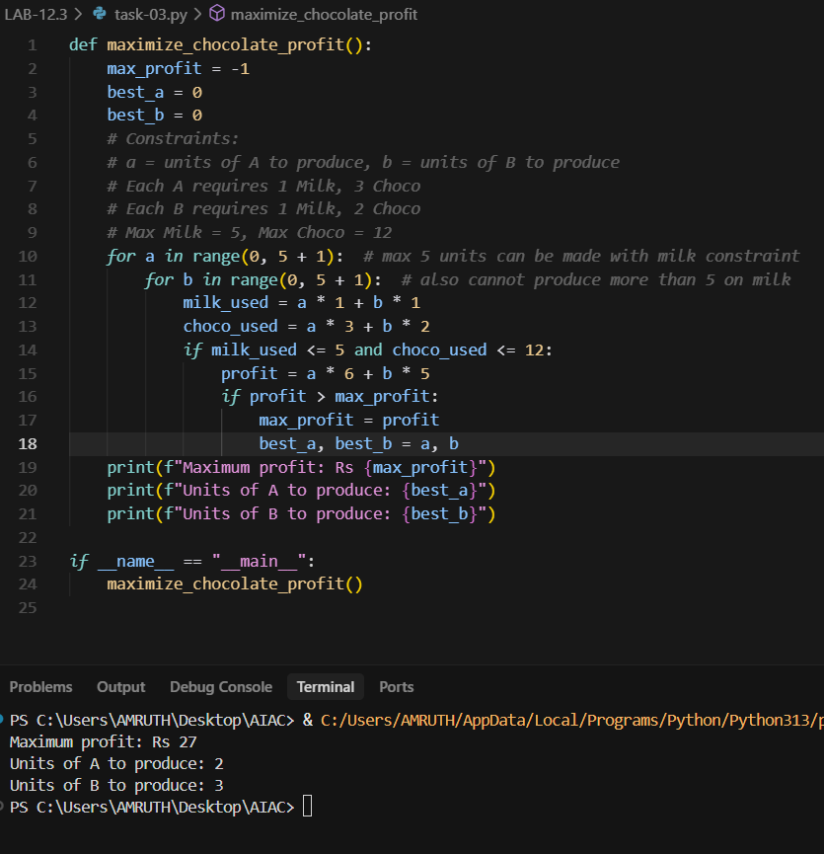  Task Description #4 – Gradient Descent Optimization  Task: Write python code to find value of x at which the function f(x)=2X³+4x+5 will be minimum  CODE & OUPUT:  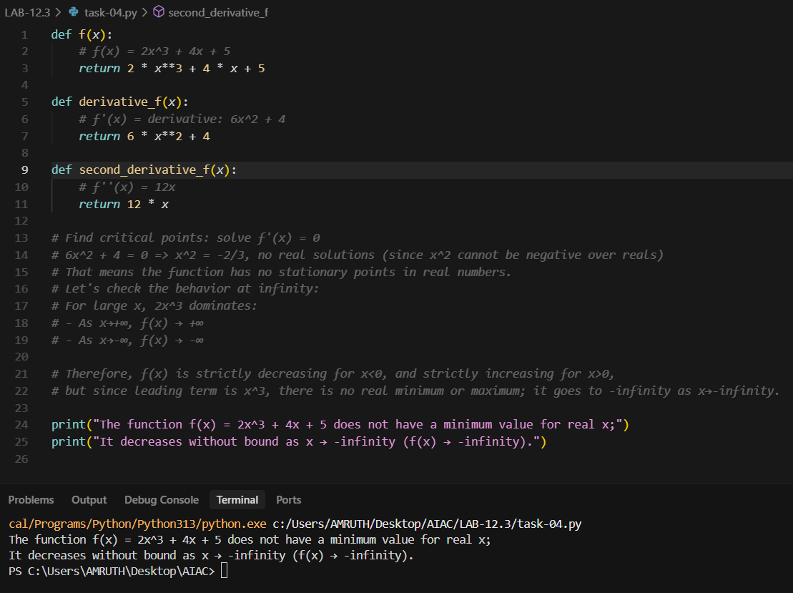 |  |  |  |  |  | Week5 - Monday

